Project report on

MEDICINE STOCK management system

*Submitted in Partial Fulfillment of the Requirements for the Degree Of*

**BACHELOR OF COMPUTER APPLICATION**

**North Lakhimpur college (autonomous)  
2017**



GUIDED BY

**Mrs. Rupashree Bhuyan (B.E., MCA)**

ASSOCIATE PROFESSOR

DEPARTMENT OF COMPUTER SCIENCE AND ENGINEERING

North Lakhimpur College (autonomous)

SUBMITTED BY

Mukunda Madhab Borah

Roll no. 14BC013

BCA 6th semester

**DEPARTMENT OF COMPUTER SCIENCE**

**CONTENTS**

CHAPTER 1: INTRODUCTION AND OVERVIEW ……………………………………………..….1-2

1.1 Introduction …………………………………………………………………..1

1.2 Project Profile ………………………………………………………………..1

1.3 Scope of the project………………………………………………………...2

CHAPTER 2: SURVEY OF TECHNOLOGIES ………………………………………………………..2-2 2.1 Survey of technologies..……………………………………………………2

CHAPTER 3: REQUIREMENT AND SPECIFICATION ……………………………………………….……………...3-4

3.1 Analysis …………………………………………………………………….3

3.1.1 Hardware requirement……………………………………………………..3

3.1.2 Software requirement……………………………………………………………………4

CHAPTER 4: SYSTEM DESIGN ……………………………………………………………………………5-6 4.1 E-R Diagram………………………………………………………………………5 4.2 Project Planning………………………………………………………………….6

Abstract:

1

The “Medicine stock Management System” is a software solution which allows a medicine stock holder or medicine distributor to manage the stock details and distribute medicines to the pharmacies or customers and their details. This can be done through the internet and local area network environments.

Some of the problem faced by manual stock management systems are delays in product distribution, maintain the details, filing of records are not easy. The chance of loose of records is high and also record searching is difficult and takes lot of time and effort.

CHAPTER 1 **INTRODUCTION AND OVERVIEW**

1.1-Introduction:

This project entitled as “Medicine stock Management System” will help to make the new stock stored process of Medicine easier. Now-a days, it is difficult to keep track the status of different types of medicines in the present scenario in the stock house. In this project we computerize this part of stock management process of medicine, so that it is easy to keep track the status of medicine. The “Medicine stock Management System” is a web-based program aimed to make easier and more convenient way for the stock managing process. The purpose of implementing this project is to understand the data modeling concepts that is used in a real time scenario and to implement a fully functional database system which interacts with a front end interface. The system is developed with a front-end web interface coded using PHP and a back-end database MySql.

1.2-Project Profile:

2

Project title: “Medicine stock Management system”

Organization involved: North Lakhimpur College (autonomous)

Hardware Requirements: Processor: Pentium

RAM: 512 MB or Higher

Disk Space: Minimum 100 MB

Platform/Language: HTML, PHP, CSS

DBMS: MySql

Web Server: Apache

Guide: Mrs. Rupashree Bhuyan (B.E., MCA)

Associate Professor

Dept. Of Computer Science,

North Lakhimpur College (autonomous)

Submitted by: Mukunda Madhab Borah (14BC013)

BCA 6th semester

North Lakhimpur College (autonomous)

1.3-Purpose of the project:

The “Medicine stock Management system” is an application which allows any

Drug store holder to manages, store and distribute medicines to pharmacies or to customers.

In this module the particular admin can add a new stock, update the stock details and

Delete details of a particular stock.

The main purpose of this SRS document is to illustrate the requirements of the project

“Medicine stock management system” and is a stored repository of medicinal stocks.

1.4-Scope of the Project:

3

a) It provides easy search technique of medicine by simply type batch number.

b) Alert message for expired medicines.

c) Updating the records easily.

d) The scope of the project is to maintain the stock management and billing system manually.

1.5-Definitions, Acronyms and Abbreviations:

**Contact details:** Details of contact associated with the customer.

**SRS:** System requirement Specification

**WWW**: World Wide Web

**Administrator:** A Login Id and password representing the admin is an administrator &

Can access all the records details

1.6-Tecnologies:

* PHP.
* MYSQL
* JAVASCRIPT
* HTML
* CSS

4

1.7-Overview:

The rest of this SRS is organized as follows:

**Section 1** gives an overall description of the software. It gives what level of proficiency is expected of the admin, some general constraints while making the software.

**Section 2** gives specific requirements which the software is expected to deliver. Some performance requirements and constraints are also given and deal with other Non-Functional Requirements.

**Section 3** deals with External Interface Requirements like Hardware and Software Interface.

CHAPTER 2 **OVERALL DESCRIPTION**

5

2.1-Product perspective:

The whole process of managing stock and distributing to the customers, was done manually till date. Processing the management and distribution of medicines to the customers used to take time when the software was not installed. The proposed system is to make easier and convenient way of managing stock and distribution of medicines.

2.2-Product Functions:

There is only one user who will be using this system:

* + - * Administrator who can add, view and update the details of the medicines.

The features that are available to the Administrator are:

* Taking backup of the database.
* Editing/deleting/creating the database.
* Changing the password.
* Change and add new administrator.

2.3-User classes of Characteristics:

There is only one user who will be using this system:

The users include:

* + - * Administrator.

2.4-Operating Environment: The product can run on any browser.

2.5-Constraints:

* Every user must be comfortable using computer.
* All operations are in English so user must have basic knowledge of English.

2.6-Functional Requirements:

6

* The Administrator has the power to (enable/disable/ update) .

* The system can be accessed anytime.

2.7-Non-Functional requirements:

2.8-usability Requirements:

The website should be user friendly and should require least effort to operate.

2.9-Portability Requirements:

The website is made using HTML, CSS, PHP, etc. Which are platform independent and can be transported to other servers with minimum effort.

2.10-Availability Requirements:

Administrator can use the system at any time maintain stock details and distribution of medicines.

2.11-Conclusion:

This SRS has given all the details of the application need to be built.

CHAPTER 3 **DESIGN PHASE**

7

3.1-INTRODUCTION:

3.1.1-Scope and Purpose:

The purpose of the design phase is to develop a clear understanding of what the developer want people to gain from his/her project. As you the developer work on the project, the test for every design decision should be "Does this feature fulfill the ultimate purpose of the project?"

A purpose statement affects the design process by explaining what the developer wants the project to do, rather than describing the project itself.

The Design Document will verify that the current design meets all of the explicit requirements contained in the system model as well as the implicit requirements desired by the customer.

3.1.2-Overall System Design activities:

The overall system design objective is to provide an efficient, modular design that will reduce the system’s complexity, facilitate change and result in an easy implementation. This will be accomplished by designing strongly cohesion system with minimal coupling. In addition, this document will provide interface design models that are consistent user friendly and will provide straight forward transition through the various system functions.

3.1.3-Structure of design Document:

System Architecture Design – The System architecture section has detailed diagram of the system, server and client architecture.

Data Design – The data Design include an ERD as well as Database design. Functional Design Description – This section has the functional partitioning from the SRS, and goes into great detail to describe each function.

8

3.1.4- FOLLOWING STEPS ARE PLANNING MEDICINE STOCK MANAGEMNT SYSTEM :

STEP 1: Study of the existing medicine stock management system of different product types of medicine types of medicine and preparing billing system automatically.

STEP 2: Draw the ER, DFD diagram and create RDBMS.

STEP 3: Prepare project proposal and submit.

STEP 4: Collect various technologies, which are required for project development, i.e.; hardware software etc and these are systematic.

STEP 5: Create various WebPages and write SQL query for insert, update, delete data in database.

STEP 6: Testing the project and prepare project report.

CHAPTER 4 **SYSTEM ARCHITECTURE DESIGN**

9

4.1-SYSTEM ARCHITECTURE:

The MSMS is a system which contains major part which include: Administrator has a privilege to create, modify, delete the stock details and customer information.

The administrator selects one of the available options as an input to the system. According to the input by the administrator the system acts and the rest of the functions are performed accordingly. The administrator can operate on any stock details.

Web Browser

Transaction Management for OES Database

Security manager OES Appointment manager Data import Report generation

And export

Login Role checking Forms and Data validation

nager

Architecture of system architecture diagram

CHAPTER 5 **DATA DESIGN**

10

5.1**: ER Diagram:**

**Buy**

**Customer**

**Product**

Has

1

N

M N

**Stock**

Supplies

**Supplier**

N

11

**5.2 0 level dataflow diagram:**

**stock**

**Management**

**System**

**0**

CUSTOMER

**SUPPLIER**

**Request for order**

**stock**

**Details**

ADMIN

**Response for order**

**Purchase order**

**Purchase info**

**1 level dataflow diagram:**

12

Pay bill and receive

receipt

Customer

Products or

Bill

Medical store

Management

system

Products or Bill

Buy or ask

Staff

Vendor

Deal by

**5.3 Design Phase Conclusion:**

14

Hence we can conclude that the design phase of the SIS give us the information of all the processes

Used in the project and their relation.

**Chapter 6 TECHNOLOGY OVERVIEW**

15

The technology selected for implementing Student Information Management System is PHP/MYSQL Apache is used as the HTTP server. The development was done in a ‘windows’ environment using adobe Dreamweaver CS5.

**6.1 PHP:**

PHP is a general-purpose scripting language that is especially suited to server-side web development where PHP generally runs on a web server.PHP code is embedded into the HTML source document. Any PHP code in a requested file is executed by the PHP runtime, usually to create dynamic web page content. It can also be used for command-line scripting and client-side GUI applications. PHP can be deployed on many web servers and operating systems, and can be used with many relational database management systems (RDBMS). It is available free of charge, and the PHP Group provides the complete source code for users to build, customize and extend for their own use.

**6.2 MySQL:**

MySQL is a relational database management system (RDBMS)[[1]](http://en.wikipedia.org/wiki/Mysql#cite_note-0) that runs as a server providing multi-user access to a number of databases. MySQL is a popular choice of database for use in web applications and is an open source product. The process of setting up a MySQL database varies from host to host, however we will end up with a database name, a user name and a password. Before using our database, we must create a table. A table is a section of the database for storing related information. In a table we will set up the different fields which will be used in that table. Creating a table in phpMyAdmin is simple; we just type the name, select the number of fields and click the ‘go’ button. we will then be taken to a setup screen where you must create the fields for the database. Another way of creating databases and tables in phpMyAdmin is by executing simple SQL statements. We have used this method in order to create our database and tables.

**6.3 Apache**

16

The Apache HTTP Server is web server software notable for playing a key role in the initial growth of the World Wide Web. In 2009 it became the first web server software to surpass the 100 million web site milestone. Apache is developed and maintained by an open community of developers under the auspices of the Apache Software Foundation. Since April 1996 Apache has been the most popular HTTP server software in use. As of November 2010[[update]](http://en.wikipedia.org/w/index.php?title=Apache_HTTP_Server&action=edit) Apache served over 59.36% of all websites and over 66.56% of the first one million busiest websites.

**6.4 XAMPP:**

XAMPP is a small and light Apache distribution containing the most common web development technologies in a single package. Its contents, small size, and portability make it the ideal tool for students developing and testing applications in PHP and MySQL. XAMPP is available as a free download in two specific packages: full and lite. While the full package download provides a wide array of development tools, XAMPP Lite, contains the necessary technologies that meet the Ontario Skills Competition standards. The light version is a small package containing Apache HTTP Server, PHP, MySQL, phpMyAdmin, Openssl, and SQLite.

**6.5 Creating a Database and Inserting Data:**

Now that we have run and tested Apache and PHP, the next step is running MySQL and creating a database and table which will hold information to be used by our website. In order to start MySQL, navigate to the xampp directory and run the mysql_start.bat batch file. The XAMPP package contains an application called phpMyAdmin which allows developers to administer and maintain MySQL databases.We will be using phpMyAdmin to create a database and table, and enter test data. Before testing phpMyAdmin, make sure that both Apache and MySQL are running by opening their respective batch files: apache_start.bat and

17

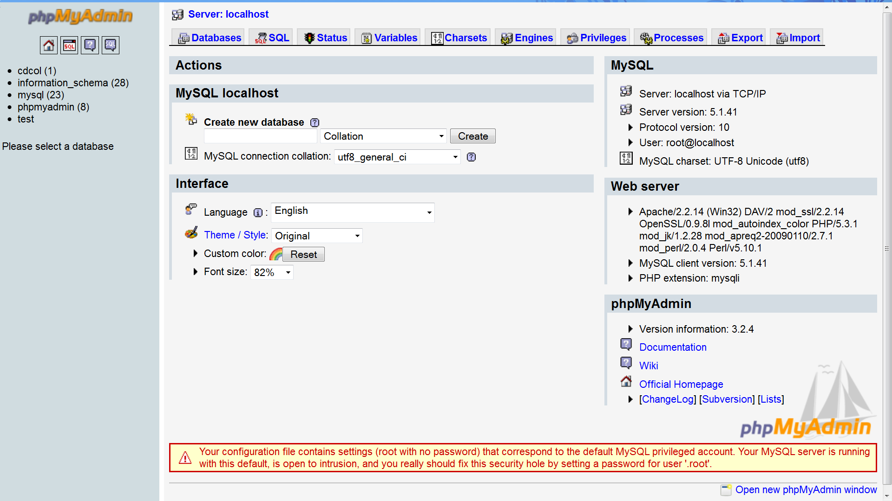

**PHP start Page**

**Chapter 7 PROJECT DESCRIPTION**

18

**7.1 Introduction**:

This project entitled as “Medicine stock Management System” will help to make the new stock stored process of Medicine easier. Nowadays, it is difficult to keep track the status of different types of medicines in the present scenario in the stock house. In this project we computerize this part of stock management process of medicine, so that it is easy to keep track the status of medicine. The “Medicine stock Management System” is a web-based program aimed to make easier and more convenient way for the stock managing process. The purpose of implementing this project is to understand the data modeling concepts that is used in a real time scenario and to implement a fully functional database system which interacts with a front end interface. The system is developed with a front-end web interface coded using PHP and a back-end database MySql.

**7.2 Description of root directory contents:**

* Adm_login.php
* Supplier_details.php
* Product_details.php
* Stock_details.php
* Update2_stock.php
* Update_stock_details.php
* Stock_sales.php

**7.3 Description of database tables:**

19

**7.3.1 Admin_database:**

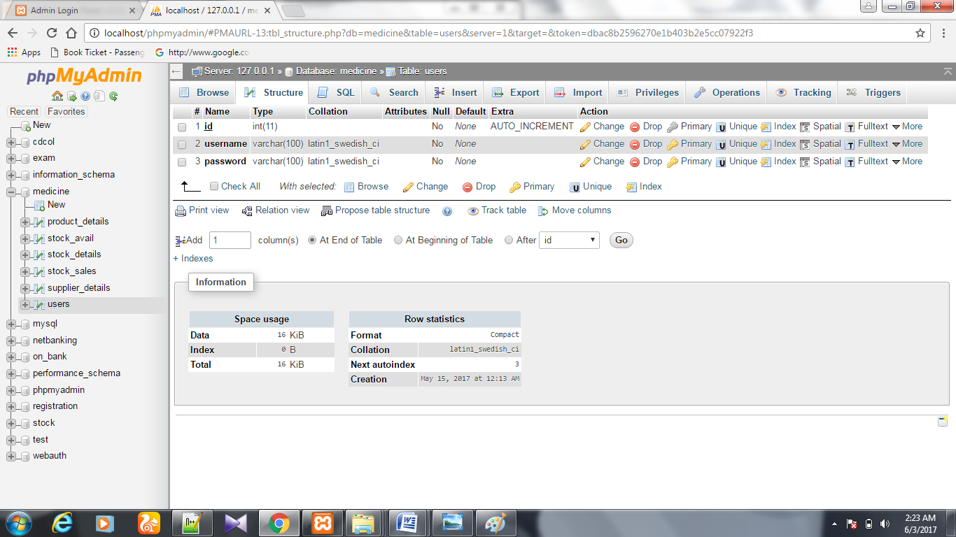

**7.3.2 Product details:**

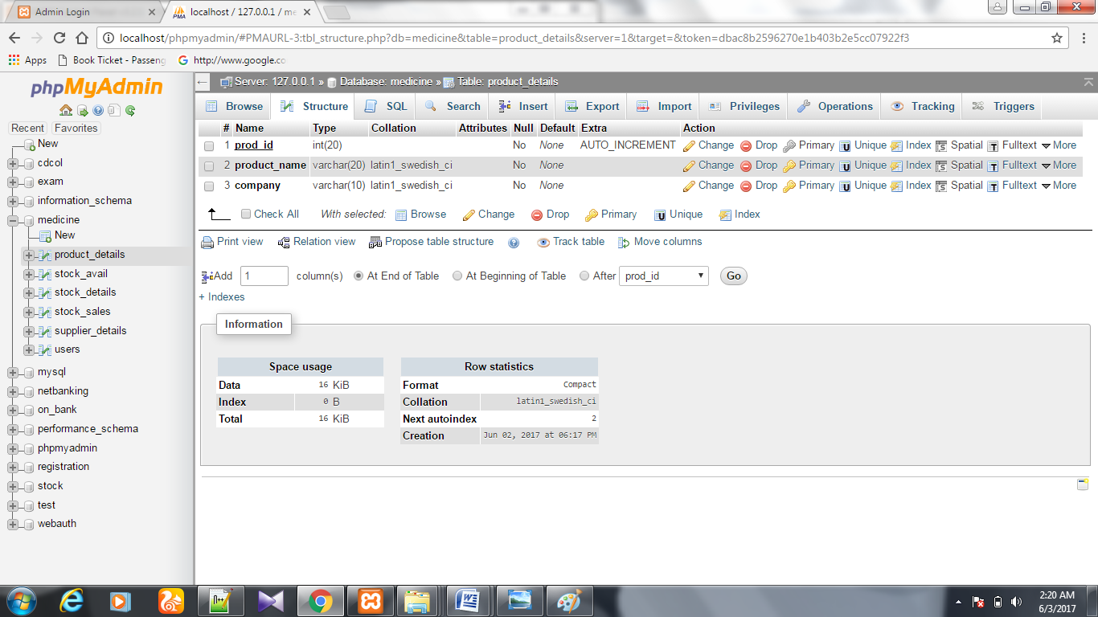

20

**7.3.3 Stock details**

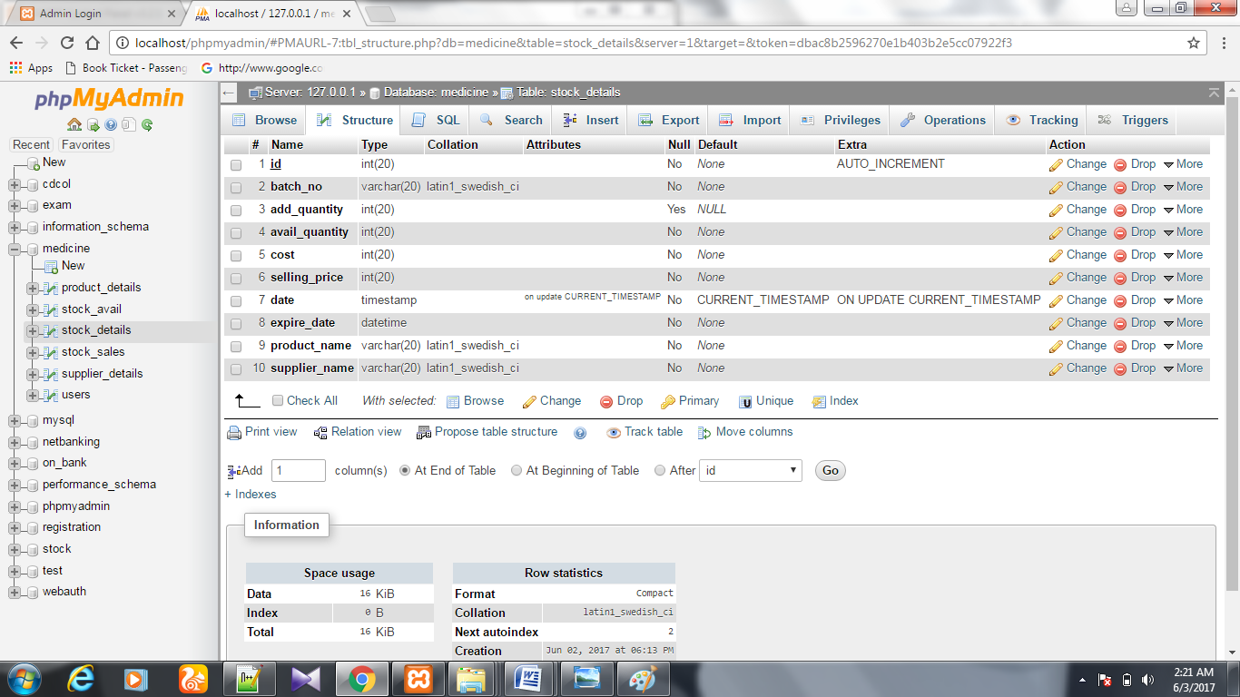

**7.3.4 Supplier details:**

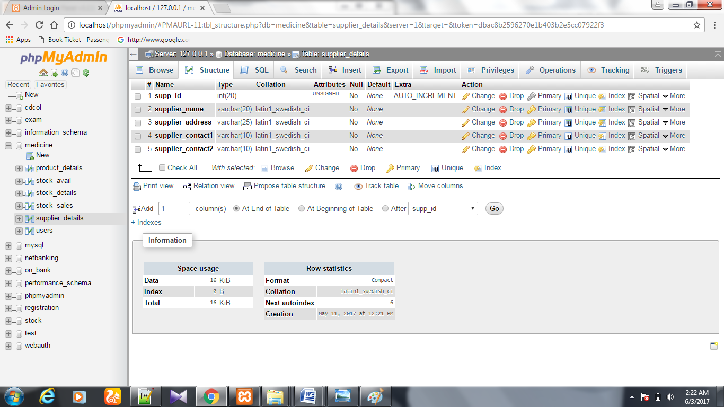

21

**7.3.5 Stock sales:**

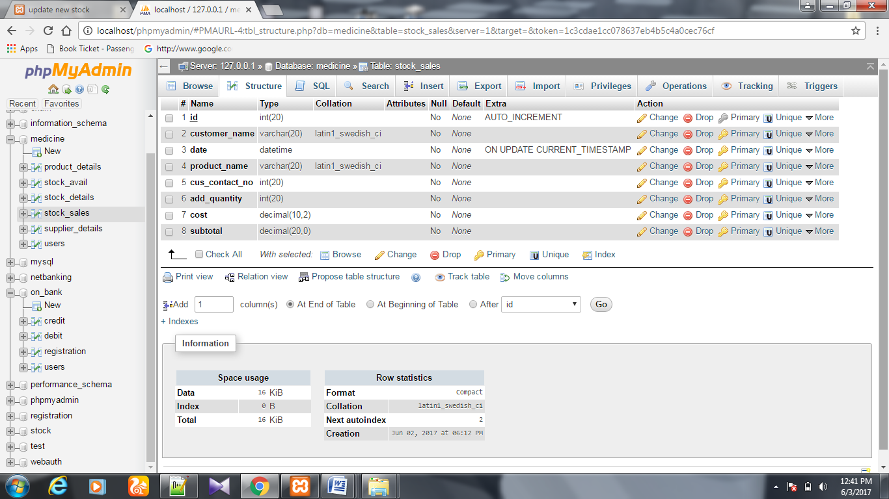

22

**Chapter 8 SNAPSHOTS**

**8.1 admin page**

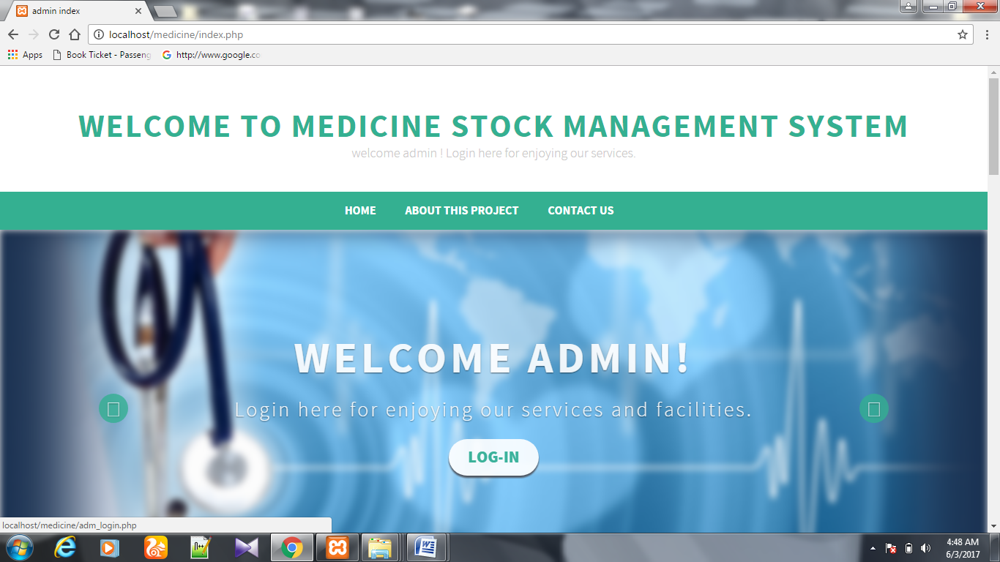

8.2 **Home Page**: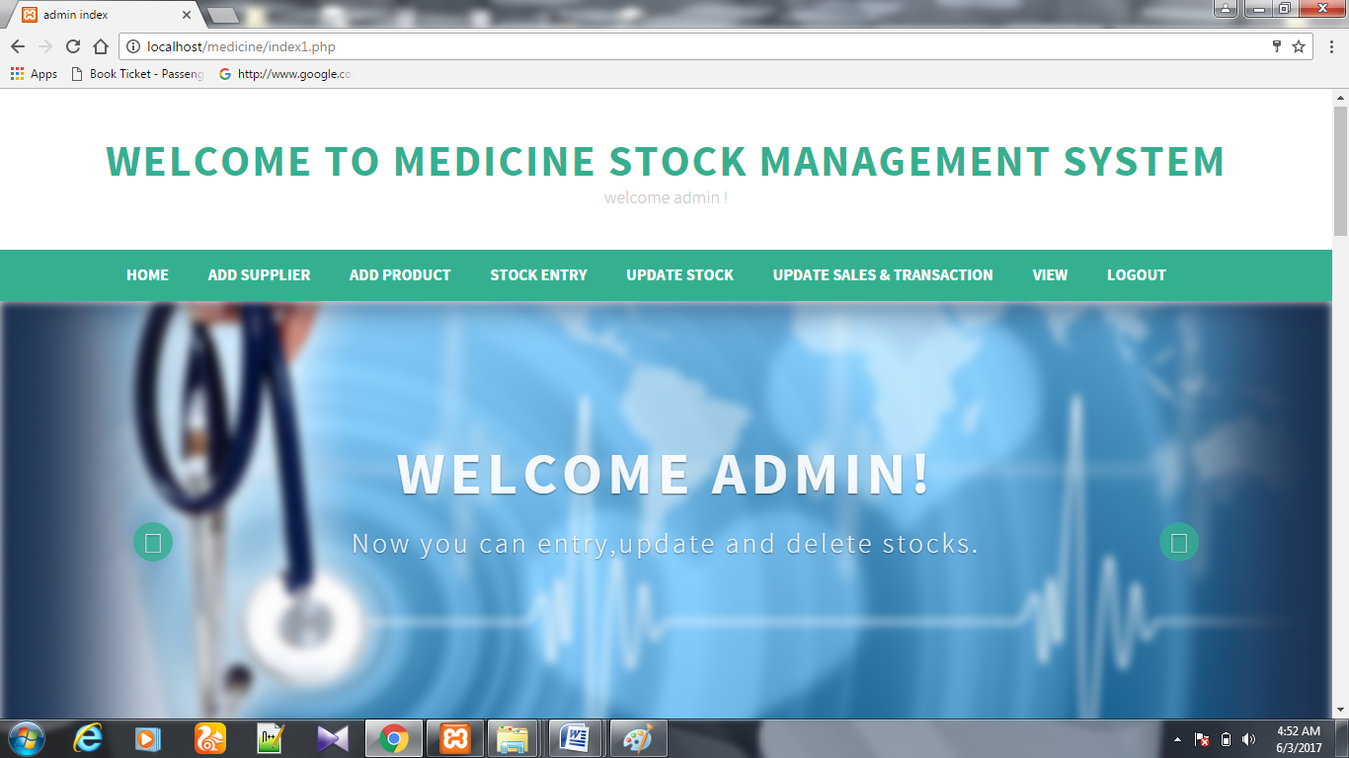

23

**8.3 Add supplier:**

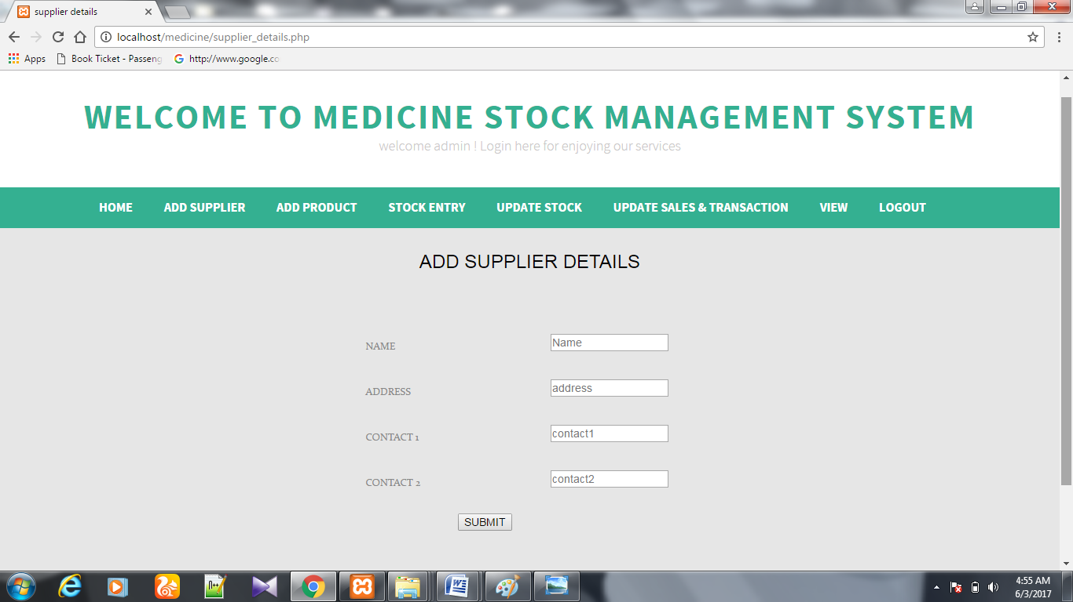

**8.4 add product details:**

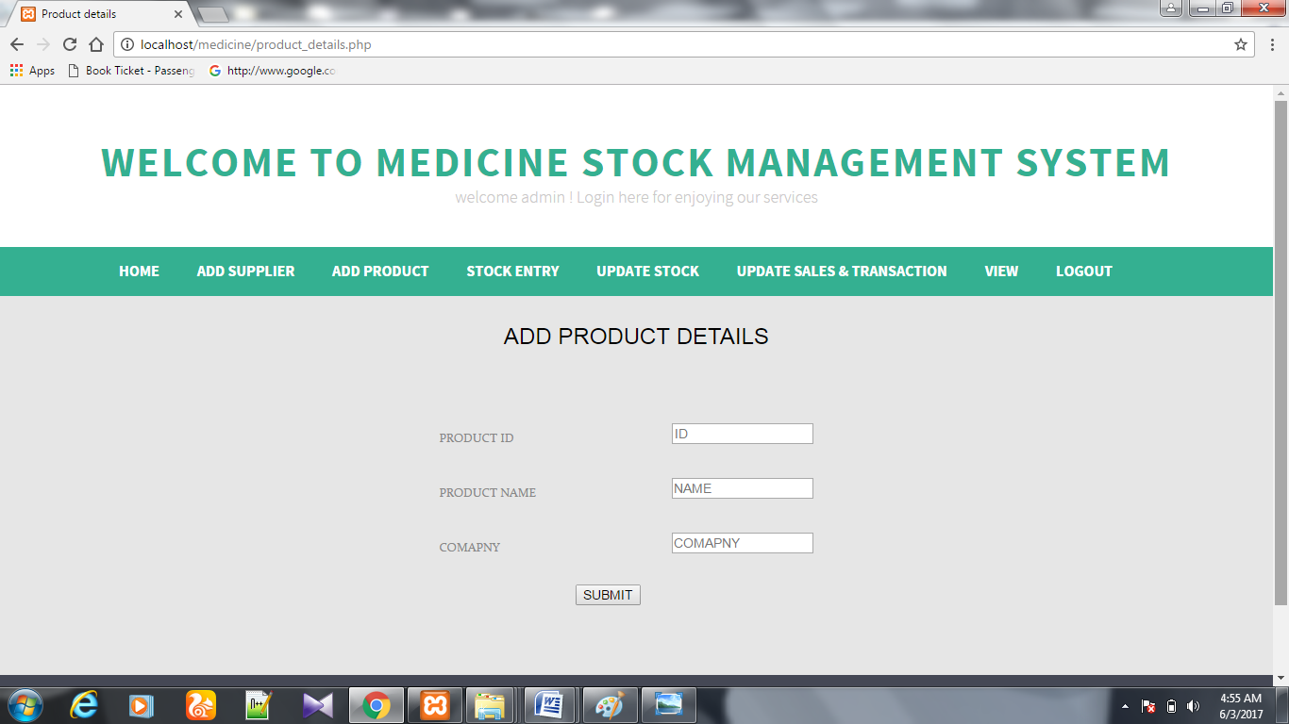

24

**8.4 add stock details:**

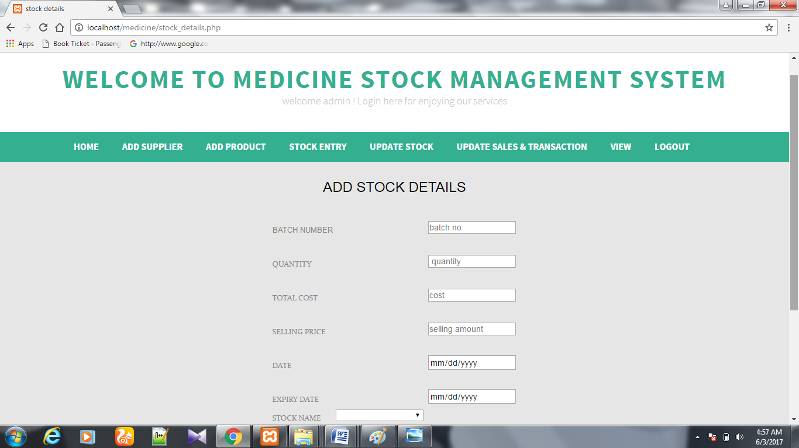**8.5 searching and updating stock:**

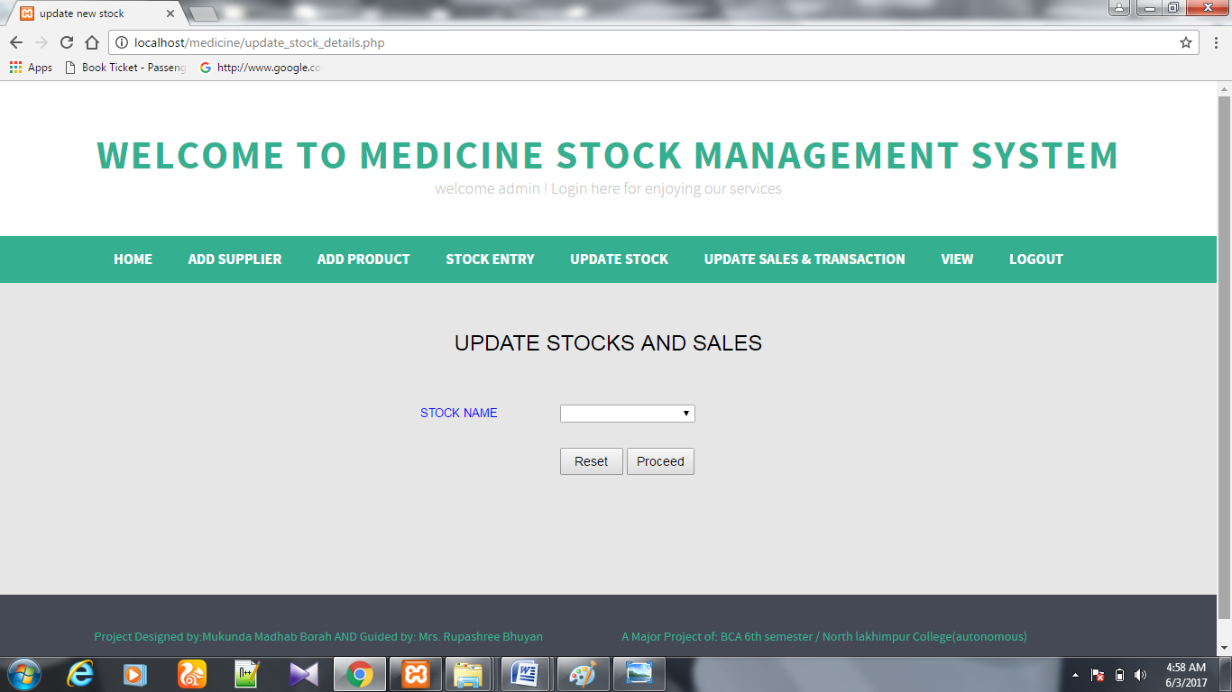

**8.6 Customer Purchase Bill:**

25

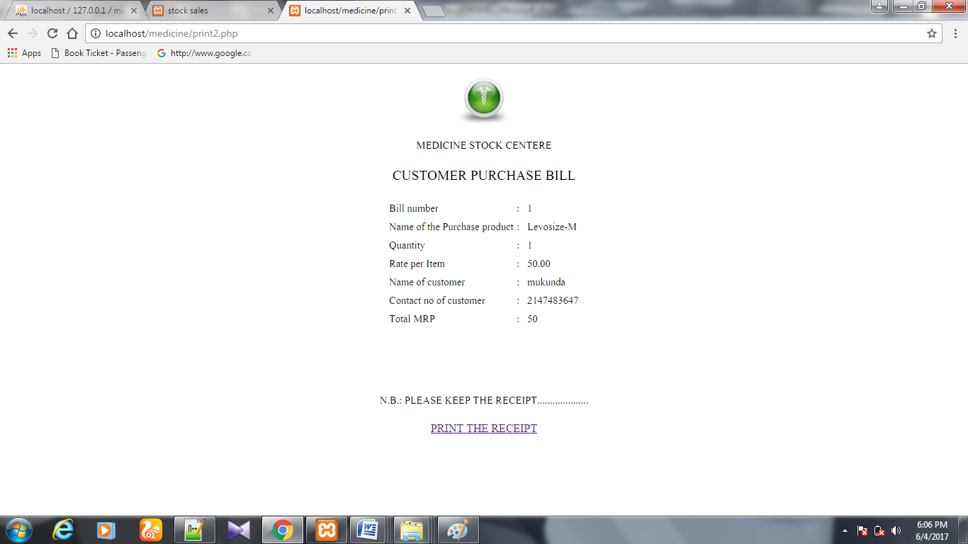

**9.1 Conclusion:**

This web application provides facility to manage the medicine stock and distribution of the medicine to the customers. It saves time as it allows the administrator to to maintain the stock details and distribute the medicine to the customers at a time and displays the stock details, so no need to do in manually and saves time. Administrator has a privilege to create, modify and delete the stock and customer details.

**9.2 Bibliography:**

26

* PHP PDF by Vasvani (TMH publications).
* Beginning PHP5 by WROX.
* [www.google.com](http://www.google.com).
* www.wikipedia.com
* www.w3schools.com
* Head First PHP & MySQL by Lynn Beighley and Michael Morrison(O’Reilly)